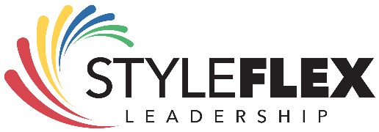
Know Yourself. Lead Well. Deliver Results
______________________________________________________________________________________
Special Leadership Albuquerque Offer
Leading with Style Workshop
Presented by Michael Kocurek | StyleFlex Leadership

Why This Workshop?
Strong leadership starts with understanding yourself—and those you lead.
For a limited time, I am offering my Leading with Style Workshop to the Leadership Albuquerque Cohort at only the cost of materials.

What You’ll Experience in this 2 ½ Hour Workshop
✔ Discover DISC – Learn the #1 behavioral style model used worldwide by leaders and organizations.
✔ Understand the History – How DISC came to be and why it’s so effective today.
✔ Personalized Assessments – Each participant receives their own DISC assessment for deep self-awareness.
✔ Keys to Communication – Learn strategies to flex your style and connect better with others.
✔ Practical Tools – Walk away with materials, your assessment, and insights you can apply immediately.

Exclusive Bonus
🎁 One-on-One Coaching Session
Every participant will also receive a 60-minute virtual coaching session (scheduled after the workshop at your convenience). Use this time to:
- Dive deeper into your DISC results
- Discuss leadership challenges
- Explore personal growth goals

Investment in Your Team
💲 Only $59 per participant (plus applicable taxes)
📌 Up to 15 people per workshop

Reserve Your Workshop Today
📞 Michael Kocurek 505.681.8727
📧 michael@styleflexleadership.com


